Assignment: LMS Backend and Perform Cross-Browser Testing
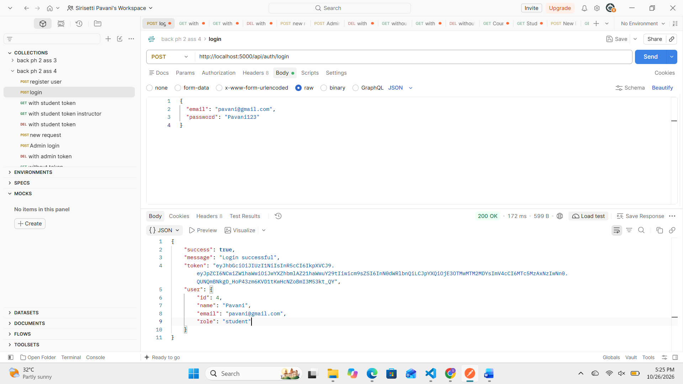
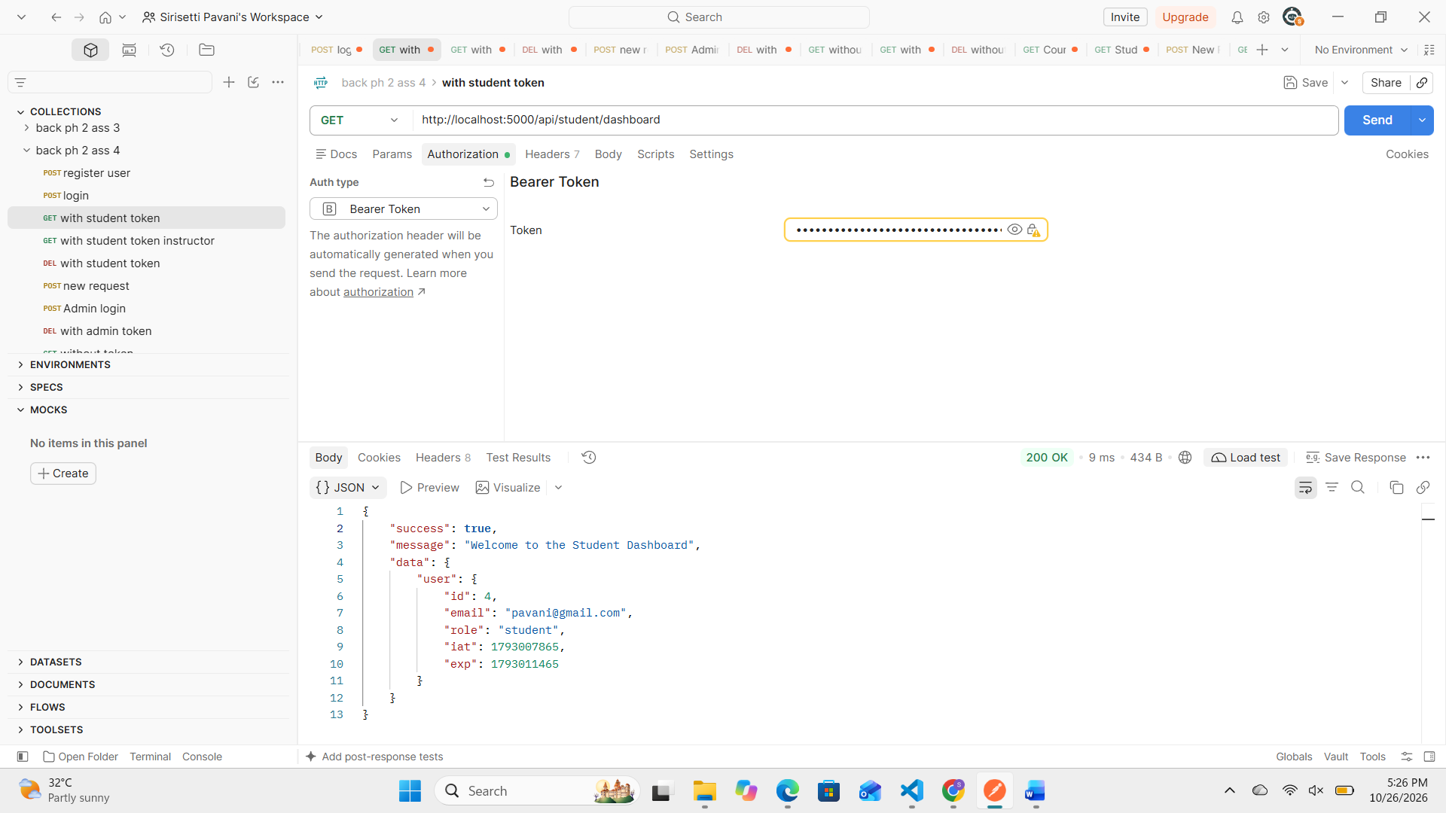
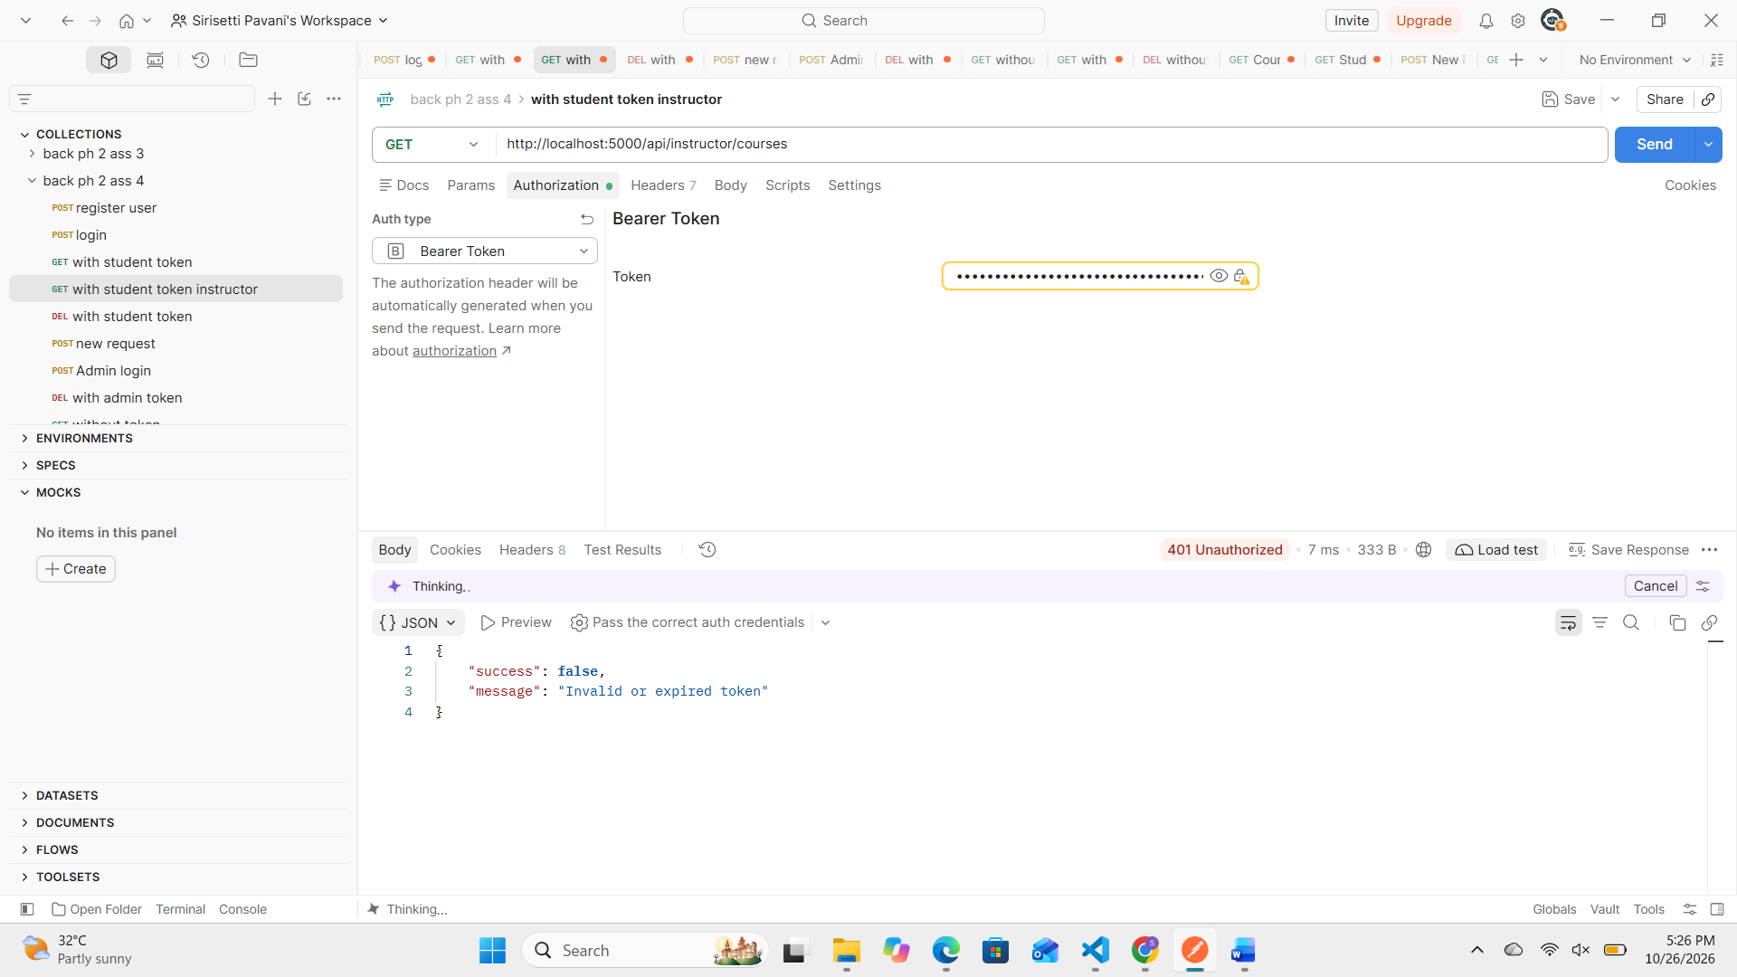

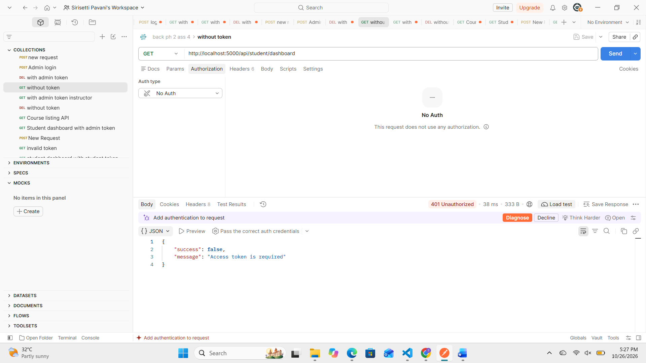
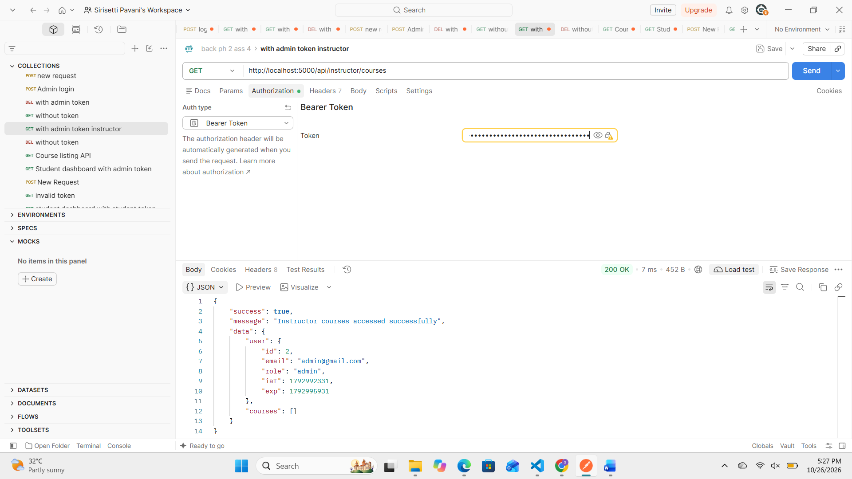

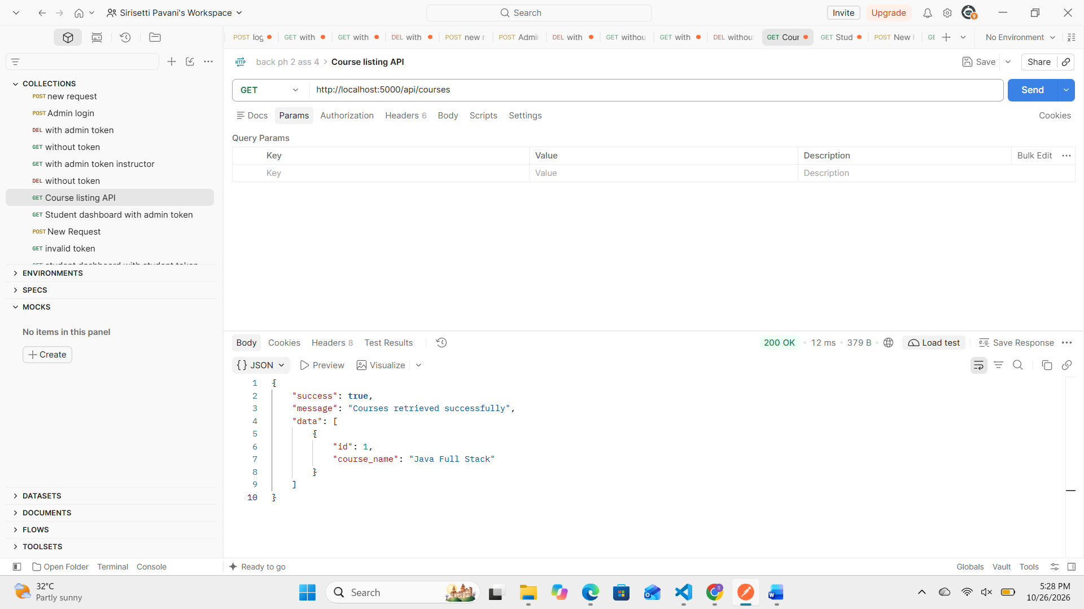

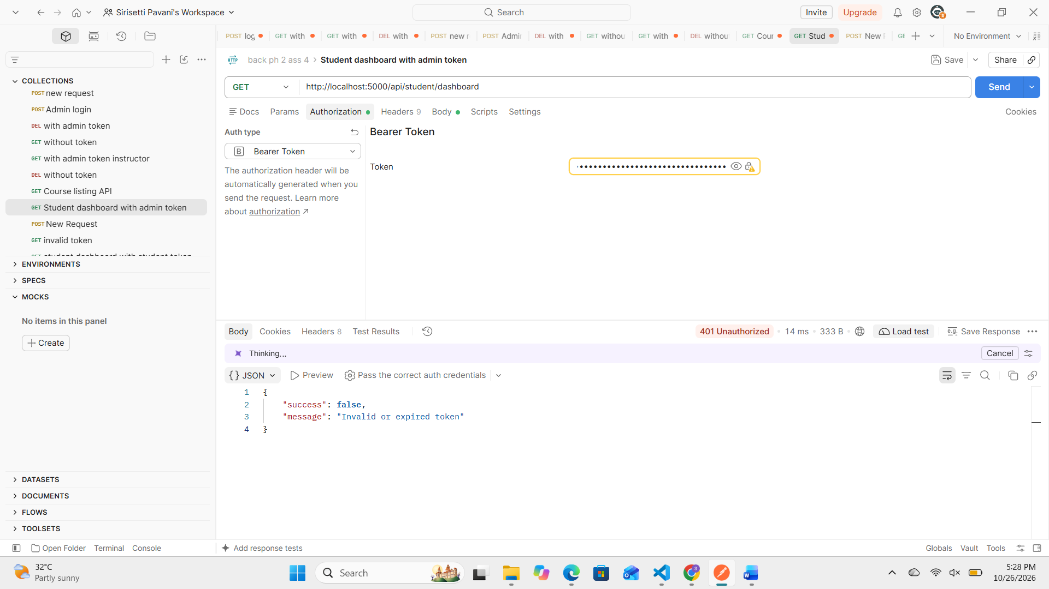

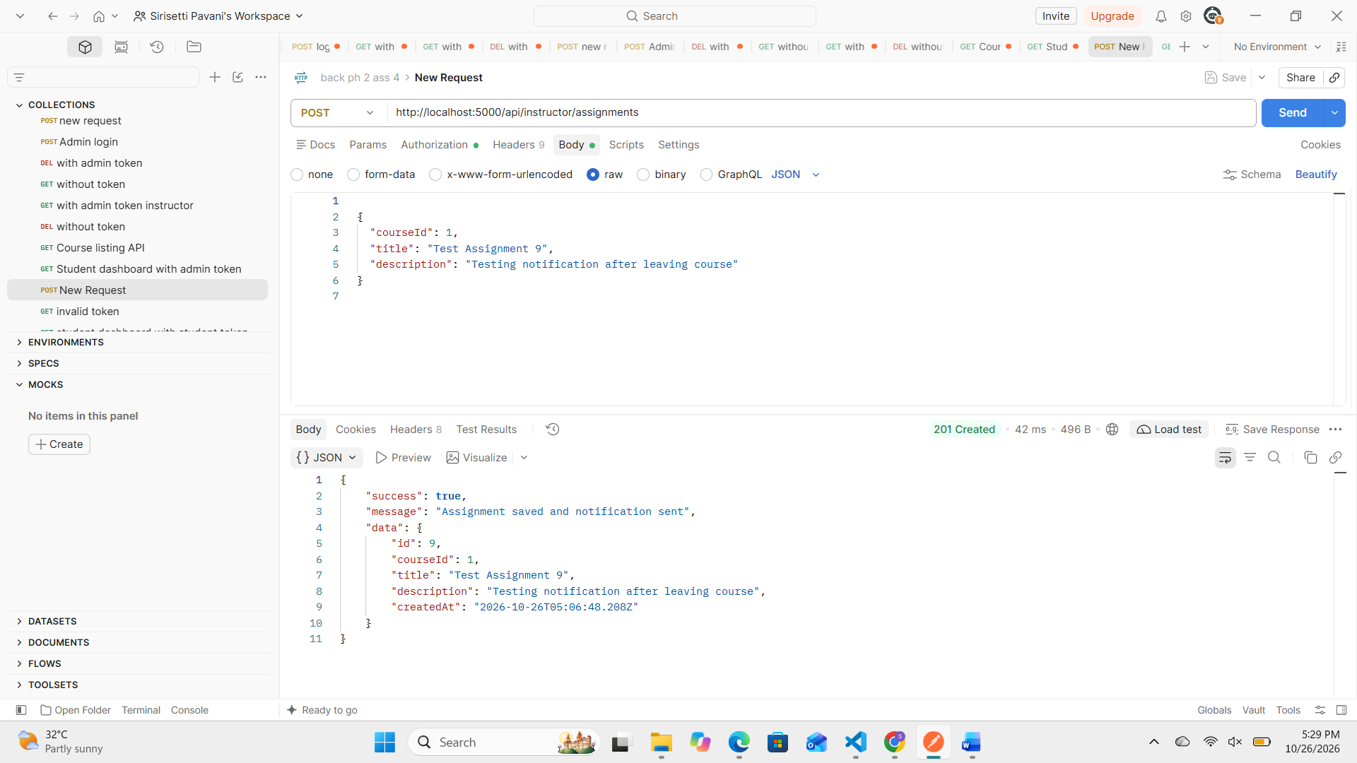
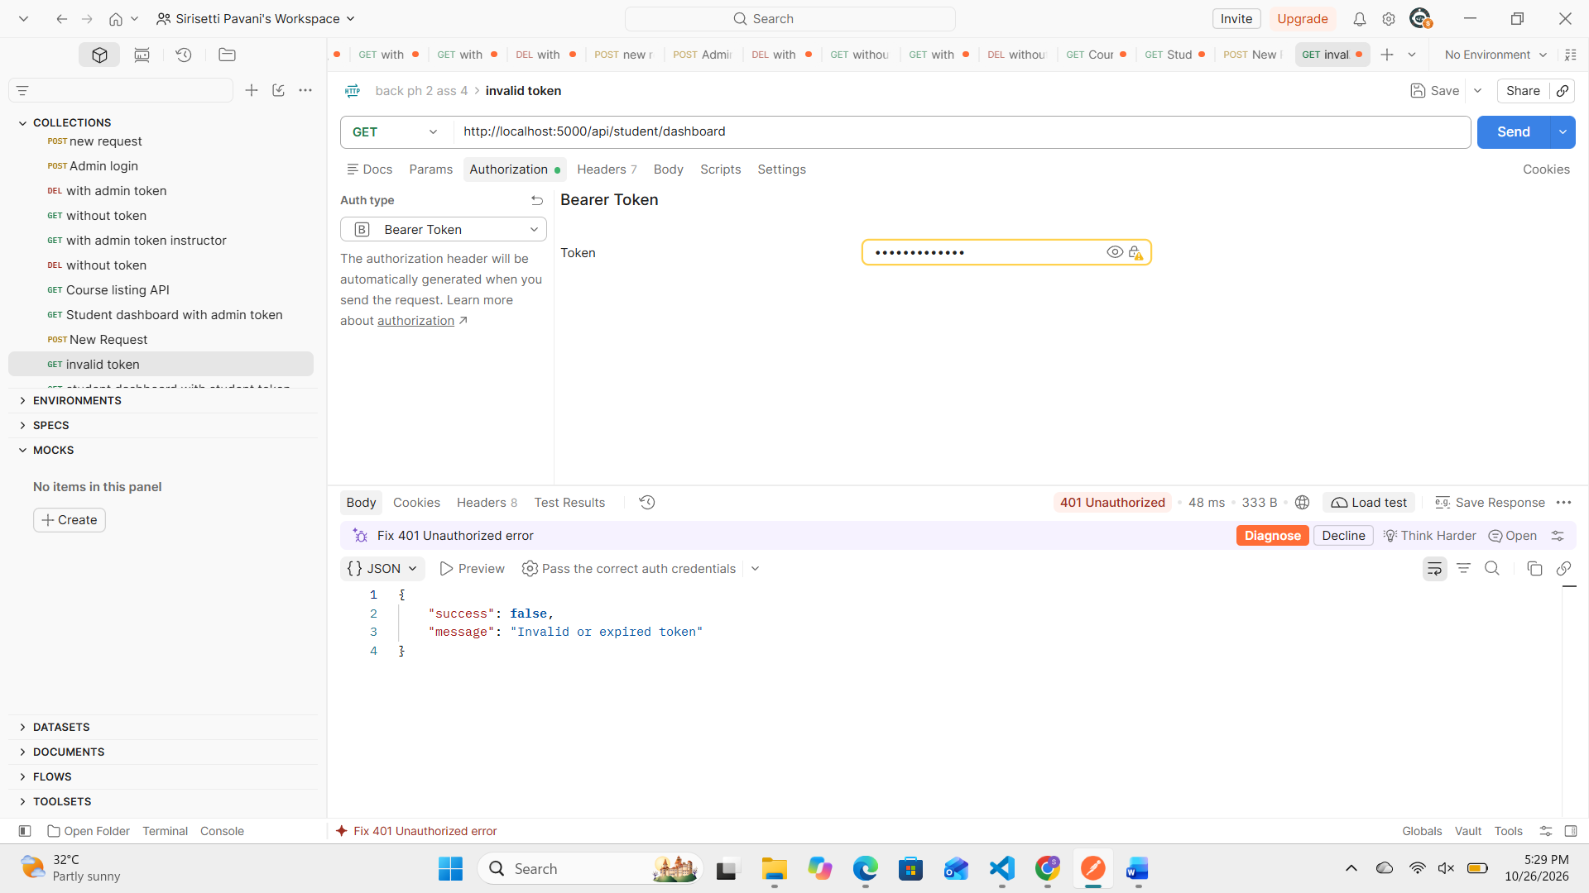

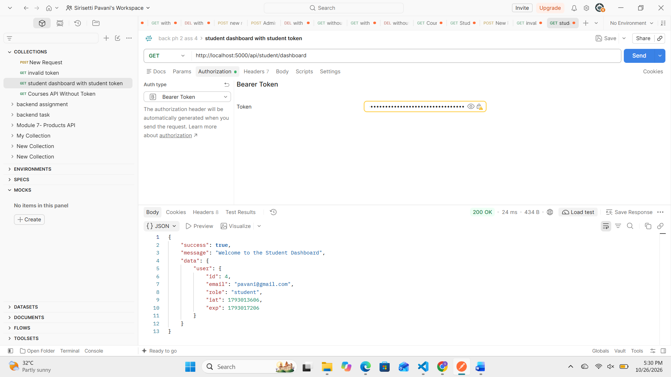
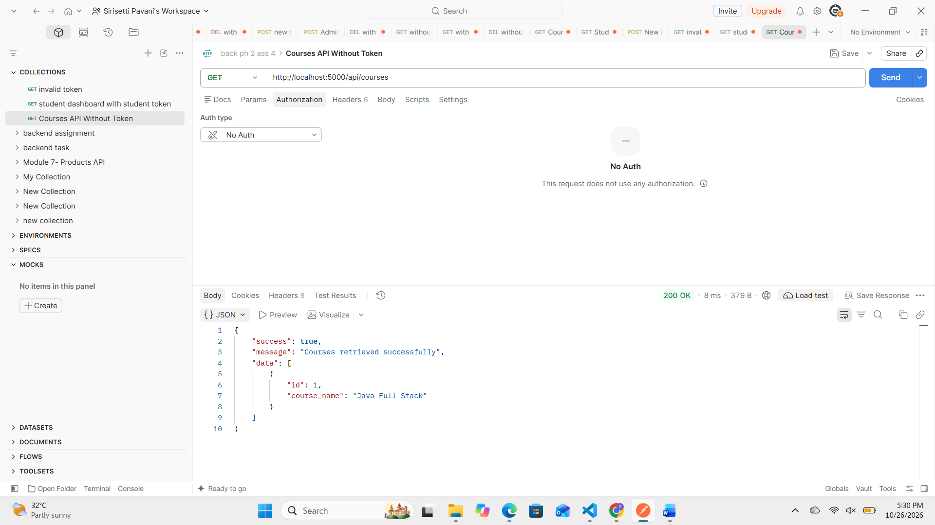

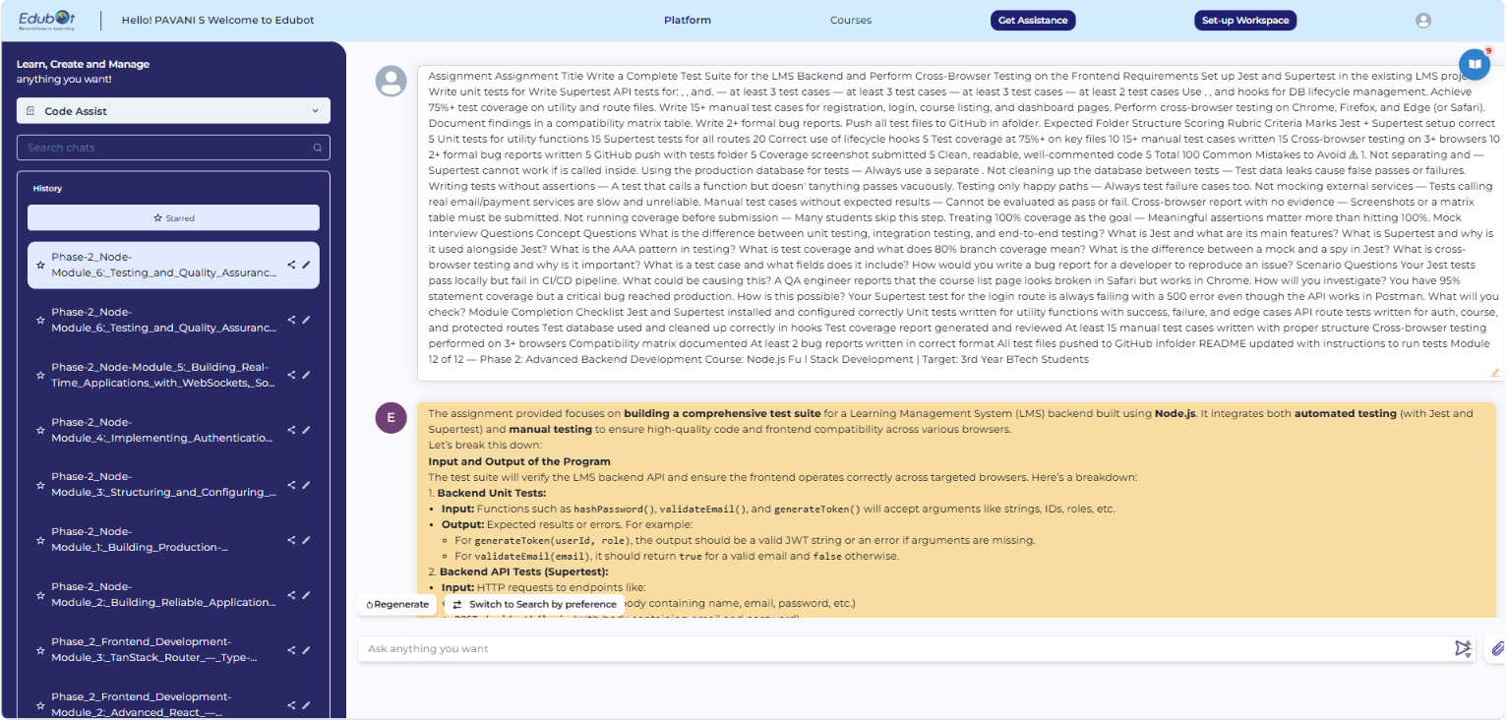

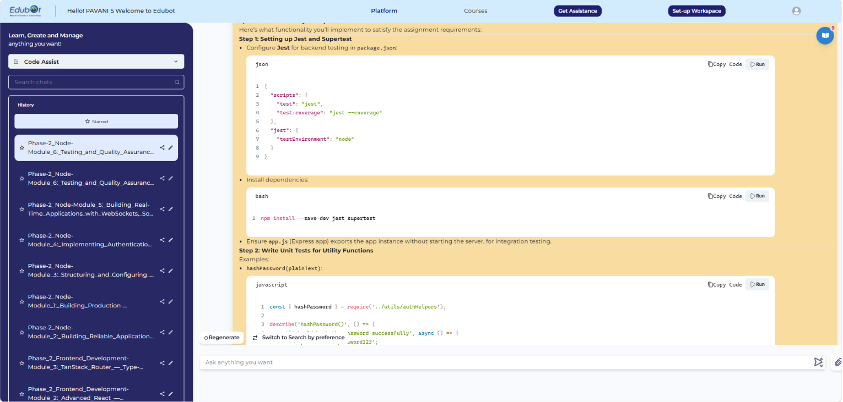
GitHub link:

LMS Backend and Perform Cross-Browser Testing
1. Introduction
The purpose of this project is to test the Learning Management System (LMS) backend APIs and verify frontend functionality across different web browsers. The project uses Jest and Supertest for automated testing and manual testing to validate registration, login, course listing, student dashboard access, and real-time assignment notifications.
The testing process helps identify errors, verify expected behavior, and improve the reliability and quality of the application.

2. Objectives
- Configure Jest and Supertest in the existing LMS project.
- Write unit tests for utility functions.
- Test authentication and API routes.
- Verify student dashboard authorization.
- Test course listing functionality.
- Use database lifecycle hooks to manage test data.
- Achieve at least 75% test coverage on utility and route files.
- Perform at least 15 manual test cases.
- Conduct cross-browser testing.
- Prepare a browser compatibility matrix.
- Document reproducible defects and testing observations.
- Push test files and documentation to GitHub.
3. Tools and Technologies
- Node.js: JavaScript runtime for the backend.
- TypeScript: Used to develop the backend application.
- Express.js: Handles HTTP requests and API routes.
- Jest: Testing framework for unit and automated tests.
- Supertest: Used to test HTTP endpoints.
- MySQL: Stores application data.
- Socket.IO: Supports real-time communication and assignment notifications.
- Postman: Used for manual API testing.
- Microsoft Edge and Google Chrome: Used for browser compatibility testing.
- Git and GitHub: Used for version control and source code submission.
4. Automated Testing
Jest is used to execute tests and validate expected outcomes. Supertest is used to send HTTP requests to the application and check status codes and response data.
4.1 Unit Testing
Unit tests are written for the following utility functions:
- generateToken(): Tests token generation.
- hashPassword(): Tests password hashing.
- validateEmail(): Tests email format validation.
These tests should cover successful inputs, invalid inputs, and relevant edge cases.
4.2 API Testing
The assignment requires automated tests for the following endpoints:
- POST /api/auth/register — at least three test cases.
- POST /api/auth/login — at least three test cases.
- GET /api/student/dashboard — at least three test cases.
- GET /api/courses — at least two test cases.
The tests should verify successful requests, invalid input, authentication failures, and other relevant error conditions.
4.3 Database Lifecycle Management
The assignment specifies the use of beforeAll, afterEach, and afterAll hooks for database lifecycle management.
These hooks are intended to prepare the test environment, clean up test data between tests, and release resources after testing. A separate test database should be used instead of the production database.
4.4 Test Coverage
Code coverage measures how much of the application code is executed during testing. The assignment requires at least 75% coverage for utility and route files.
Coverage reports should be generated and reviewed to identify untested code paths. Meaningful assertions and error-case testing are important in addition to achieving the required percentage.
5. Manual Testing
Manual testing is performed by sending requests through Postman and interacting with the LMS frontend.
The manual test cases should cover:
- User registration with valid and invalid details.
- Login with correct and incorrect credentials.
- Access to protected routes with and without tokens.
- Course listing and course data retrieval.
- Student dashboard access.
- Real-time socket connection and course-room membership.
- Assignment notifications before and after leaving a course room.
Each test case should include a test case ID, scenario, preconditions where necessary, steps, expected result, actual result, and status.
At least 15 manual test cases are required by the assignment.
6. Cross-Browser Testing
Cross-browser testing verifies whether the frontend functions consistently across different browsers.
The assignment requires testing in Google Chrome, Mozilla Firefox, and Microsoft Edge, or Safari as an alternative.
The following functionality should be checked:
- LMS page loading.
- User interface rendering.
- Socket connection.
- Joining and leaving a course room.
- Receiving real-time assignment notifications.
- Handling errors and displaying status messages.
The results should be recorded in a browser compatibility matrix. A browser should be marked as passed only after the corresponding test has actually been performed.
7. Bug Reporting
A formal bug report should contain:
- Bug ID and title.
- Description of the issue.
- Preconditions.
- Steps to reproduce.
- Expected result.
- Actual result.
- Severity and priority, where applicable.
- Environment and status.
At least two formal bug reports are required by the assignment. Reports must describe reproducible issues or verified defects rather than assumed problems.
8. GitHub Submission
All test files must be maintained in the project's tests folder. The assignment also specifies a docs folder containing:
- test-cases.xlsx
- cross-browser-report.md
- bug-reports.md
The source code and documentation should be committed and pushed to the project's GitHub repository.
9. Conclusion
This project establishes an approach for validating the LMS backend and frontend through automated testing, manual API testing, and cross-browser testing. Unit tests and API tests help verify individual functions and endpoints, while manual testing checks application behavior in practical scenarios.
Coverage analysis, compatibility documentation, and formal bug reports help identify areas that require improvement and provide a clear record of the testing process.
The project is considered ready for submission after all required tests, browser checks, documentation, and coverage evidence have been completed and verified.

